MATHEMATICS SPECIALIST

MAWA Year 12 Examination 2019

Calculator-free

Marking Key

© MAWA, 2019
Licence Agreement
This examination is Copyright but may be freely used within the school that purchases this licence.
- The items that are contained in this examination are to be used solely in the school for which they are purchased.
- They are not to be shared in any manner with a school which has not purchased their own licence.
- The items and the solutions/marking keys are to be kept confidentially and not copied or made available to anyone who is not a teacher at the school. Teachers may give feedback to students in the form of showing them how the work is marked but students are not to retain a copy of the paper or marking guide until the agreed release date stipulated in the purchasing agreement/licence.

The release date for this exam and marking scheme is 14th June.

Question 1(a) (3 marks)

Solution
If
then

Alternatively we note that with and .
Then as before

Mathematical behaviours | Marks
- calculates correctly  - calculates correctly  (1 mark for showing real part zero and 1 mark for correct value of imaginary part) | 1  1+1

Question 1(b) (1 mark)

Solution
Since
then which is real and negative. Hence
Mathematical behaviours | Marks
- calculates correctly | 1

Question 2 (a) (1 mark)
Solution
Augmented matrix =

Mathematical behaviours | Marks
- correctly transfers coefficients of equations to augmented matrix | 1

Question 2 (b) (3 marks)
Solution
After $r_{2}-2r_{1}$ and $r_{3}+r_{1}$ the system is reduced to:

After $r_{2}+4r_{3}$ the system is further reduced to

Mathematical behaviours | Marks
- correctly reduces x-components to 0 for rows 2 and 3 (or equivalent)  - correctly reduces y-component to 0 for row 3 (or equivalent) | 2  1

Question 2 (c) (3 marks)
Solution
From the augmented matrix form we deduce that

(i) for unique solution, $a≠-4$
(ii) for no solution $a=-4$and $b≠-\frac{15}{4}$
(iii) for infinitely many solutions$a=-4$and $b=-\frac{15}{4}$

Mathematical behaviours | Marks
- correctly determines value of for a unique solution  - correctly determines values of and that means there is no solution  - correctly states the values of and for infinitely many solutions | 1  1  1

Question 2 (d) (3 marks)
Solution
When and the augmented matrix becomes

Then the second equation gives
and first equation then leads to
Hence the general solution of the equations is

Mathematical behaviours | Marks
- determines in terms of (or vice-versa)  - determines the value of  - states the general solution in terms of a suitable parameter | 1  1  1

Question 3 (5 marks)
Solution
If then so that
For this to be the same as the linear function then comparison of the coefficients of and the constant requires that
and
Hence so . If then so
If then is arbitrary

We conclude that either or with any real number
Mathematical behaviours | Marks
- derives equation for the inverse  - compares coefficients to determine the equations for and  - solves for  - derives correct solution for  - dervies correct solution for | 1  1  1  1  1

Question 4 (4 marks)

Solution
Let in which case ; additionally

Now
as required

Mathematical behaviours | Marks
- writes down an appropriate form for and hence  - derives an expression for  - in quotient multiplies through by the complex conjugate  - draws a valid conclusion | 1  1  1  1

Question 5 (a) (3 marks)
Solution
is defined if

If then if

If then if

So is defined for

Mathematical behaviours | Marks
- obtains positivity requirement for  - obtains lower and upper limits of the domain | 1  1+1

Question 5 (b) (3 marks)
Solution
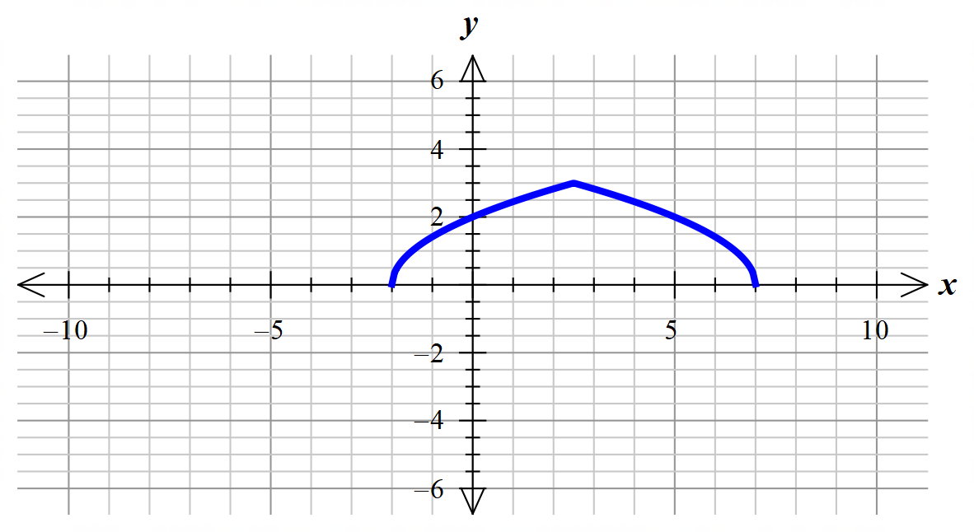

Mathematical behaviours | Marks
- displays general shape of the graph  - indicates maximum at $\left(2.5,3\right)$  - makes clear the non-differentiability at the maximum point | 1  1  1

Question 6 (a) (2 marks)
Solution
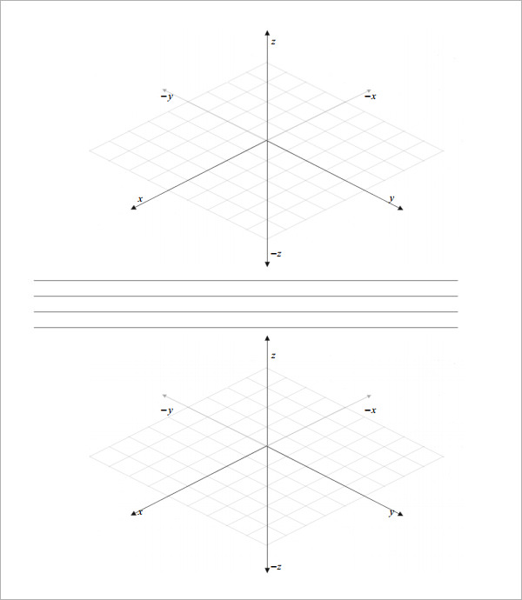
Mathematical behaviours | Marks
- correctly sketches the triangle on the plane with all three intercepts cutting the axes at (-1 for one mistake) | 2

Question 6 (b) (1 mark)
Solution
Substituting gives: $4\left(3\right)-3\left(4\right)+6\left(2\right)=12$
Now LHS $=4\left(3\right)-3\left(4\right)+6\left(2\right)=RHS$ so the given point lies on the plane
Mathematical behaviours | Marks
- correctly substitutes point into equation and confirms value | 1

Question 6 (c) (2 marks)
Solution
The vector q = 4ijk is perpendicular to Q.
Since v q, it can be concluded that v is parallel to q
As such v must also be perpendicular to Q.
Mathematical behaviours | Marks
- recognises that v is a scalar multiple of w  - concludes that v is parallel to w and so must also be perpendicular to Q | 1  1

Question 6 (d) (2 marks)
Solution
Equation for $π_{R}:4\left(x-4\right)-3\left(y-2\right)+6\left(z+3\right)=0$ so that
Mathematical behaviours | Marks
- writes down equation with same coefficients  - shows how to incorporate the fact that the required plane includes the given point | 1  1

Question 6 (e) (2 marks)
Solution
We can find w by forming the vector product

This vector, or any non-zero multiple of it, is the required perpendicular vector.
Mathematical behaviours | Marks
- makes clear the need to construct a vector product  - computes the vector product correctly | 1  1

Question 7 (6 marks)

Solution
First note that

Then for
by de Moivre’s theorem

Hence the five roots are where

Restricting the argument to the stated domain leaves

Mathematical behaviours | Marks
- writes in a suitable polar form (1 for modulus, 1 for argument)  - uses de Moivre’s theorem appropriately  - writes down the five required roots (-1 for one mistake)  - calculates all the arguments so that they lie in the appropriate given range | 1+1  1  2  1

Question 8 (6 marks)
Solution
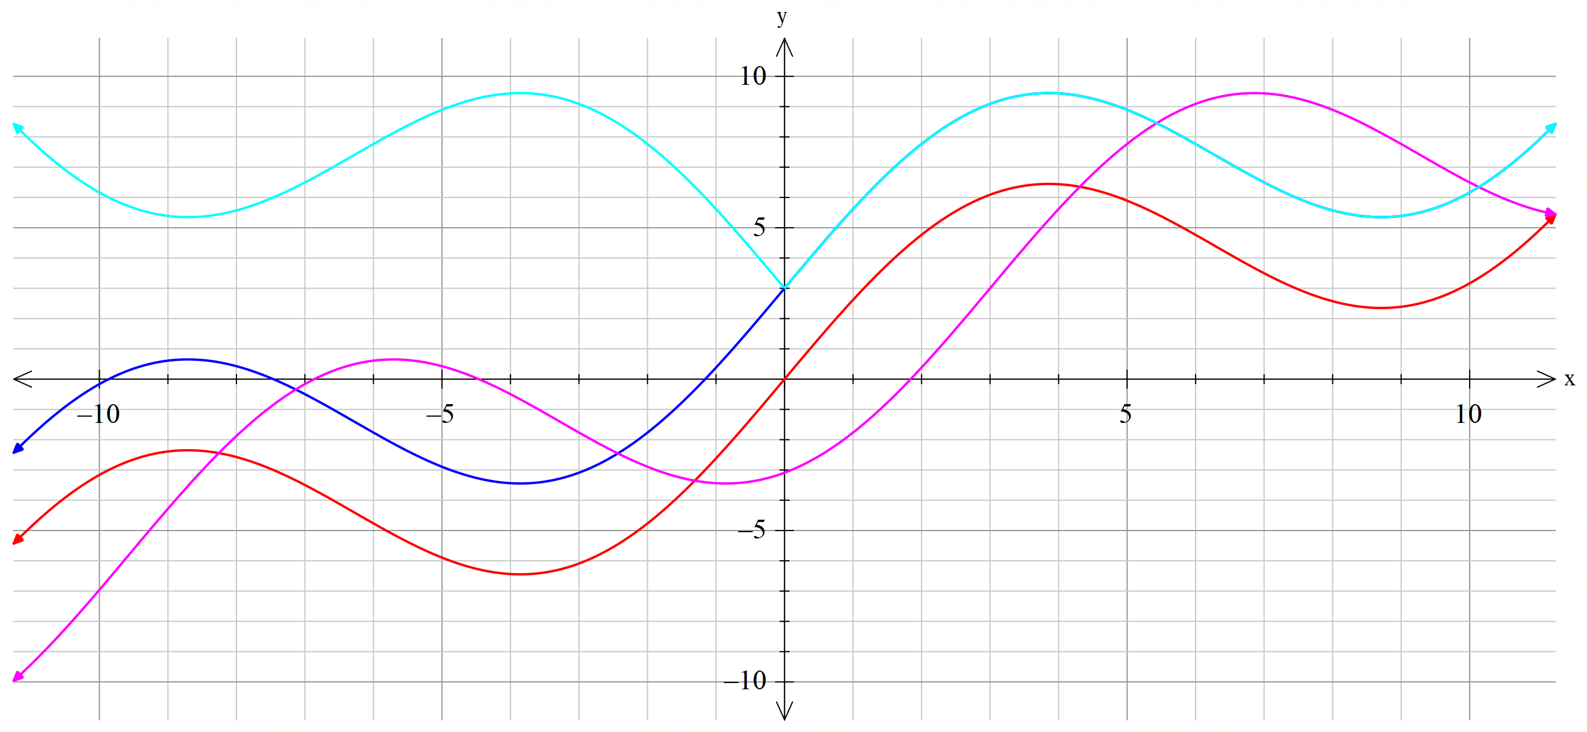

The graph of $f(x-3)$ is obtained by shifting the graph of $f(x)$ 3 units to the right.
The graph of $f(x)-3$ is obtained by shifting the graph of $f(x)$ 3 units down.
The graph of $f(\left|x\right|)$ is the same as the graph of $f(x)$ for $x≥0$ and then that part is reflected across the y-axis.
Mathematical behaviours | Marks
- displays the correct geometric transformations  - plots the graphs reasonably accurately | 1+1+1  1+1+1

